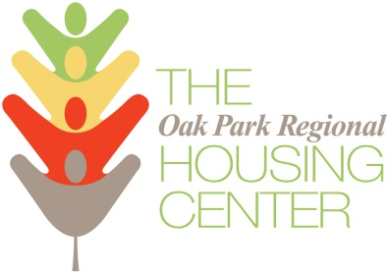

OWNER IMPROVEMENT PLAN

Owner Name: __________________________________________

Address: ______________________________________________

Number of Units: ________________________________________
Project | Unit | Room(s) | Explanation | Estimated Cost
Total: $___________

Oak Park Regional Housing Center
1041 South Boulevard
Oak Park, IL 60302

Questions – call Executive Director Rob Breymaier at 708-848-7150 x123

