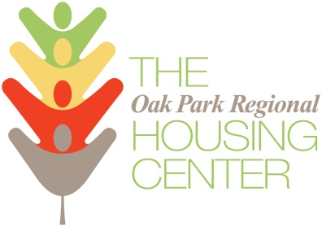

PROPERTY OWNER APPLICATION

REQUIRED APPLICANT INFORMATION (Complete one application per building)

- Owner(s) Name(s): ______________________________________________________________________________________

- Rental Property Address (include ZIP): ______________________________________________________________________________________

- Owner Address (include Apt # and ZIP): _______________________________________________________________________________________

- Owner Phone Numbers: ______________________ (home/bus) _______________________ (cell)

- Owner E-mail(s): ______________________________________________________________________

- Number of Units Requested for Funding: _____________

- Amount of Funding Requested: $_____________ per unit $_____________ total

- Number of Units in this Rental Building: ______________

- Number of Units Owned/Managed in Total: _____________

PLEASE ALSO PROVIDE (Required)
- Clear Pictures of the Exterior (front and back) of the Building
- Clear Pictures Each Room in the Unit

ELIGIBILITY CRITERIA
- Only buildings with 2 to 4 units are eligible for this program
- UNITS MUST BE VACANT
- OPRHC will offer up to $4,000 per unit for repairs and upgrades to increase the marketability of apartments.
- The Recipient must match the grant with an additional investment equal to or exceeding one-quarter of the grant amount requested.
- A pre-inspection by OPRHC staff to assess and approve the proposed scope of work is required.
- A post-inspection by OPRHC to assess and approve the completed work is required.
- Participating owners must list their improved units for the next 36 months with the Housing Center.
- Participating owners must participate in a management seminar with OPRHC.
- Participating owners must use approved contractors in this program.

PROPOSED IMPROVEMENTS
Grants are for marketability improvements, not structural repairs. The work you propose should improve the desirability of your unit.

General
☐Refinishing Floors
☐New Carpeting
☐Repainting
☐Improving Security
☐Installing Mini-Blinds
☐Replacing Lighting Fixtures
☐Improving Security
☐Installing Mini-Blinds
☐Replacing Lighting Fixtures
☐Restoring Woodwork
☐Replacing Ceiling Fans
☐Installing Ceiling Fans
☐Other ______________________

Bathrooms
☐Replacing Toilet(s)
☐Replacing Vanity
☐Refinishing Bathtub/Shower
☐Repairing Tile Work
☐Other ______________________

Kitchens
☐Replacing Countertops
☐Replacing Cabinets
☐Replacing Appliances
☐Adding Appliances
☐Other ______________________

If accepted, required documentation will include the following.
· Government Issued photo ID such as a Driver’s License, State ID or passport
· Proof of Ownership for the Applied Property
· Schedule E of prior 2 years’ tax returns
· Mortgage confirmation (if applicable)
· Trust agreement (if applicable)
· Proof of Property Insurance
· Sales Agreement (if purchased within the last 6 months)

DELIVER APPLICATIONS WITH PHOTOS TO
Oak Park Regional Housing Center
ATTN: Austin Ascending
1041 South Boulevard
Oak Park, IL 60302

Questions – Call Executive Director Rob Breymaier at 708-848-7150 x123

